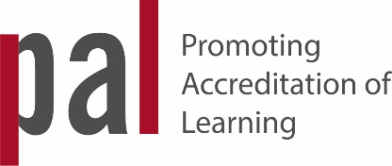 | PAL  Learning and Sharing Tracking Log

Name: |  |  |  |  |  | School/College/Centre: |  | Academic Year: |  | Date of submission:
Date: | Title of Session | Category of Activity i.e. Category 1 = participating  or  Category 2 = facilitating |  | Methodology used e.g. Café Style Workshop, Show and Tell etc. |  | Professional Development intention for attending/ undertaking the activity |  | How was learning from the PAL CPD activity Integrated into your work practice afterwards (include any incidental learning) |  | PAL Points achieved Category 1 =5 points or  Category 2 = 10 points
 |  |  |  |  |  |  |  |  | TOTAL
For office use only:
Date Received: |  |  |  |  | Reviewed by:

PAL Tracking Tool
Summary Self Evaluation / Reflection
One summary self-reflection should be submitted with the Tracking Log when the 30 PAL point cycle of activity has been completed.

Name: | Academic Year: | School/College/Centre Name:
What?
What have I learned during the PAL Learning Champion period from: 1. participating in informal / non formal learning activities? 2. facilitating informal non formal learning activities?
Transfer?
What positive results have the PAL peer learning and sharing activities had for: 1. my own performance? 2. my colleagues? 3. my students?

What next?
What do I plan to do next to: 1. support / enhance my own professional development? 2. promote peer learning and sharing within my organisation?

For office use only:
Date received:
Reviewed by:

