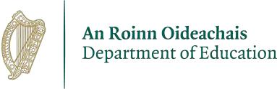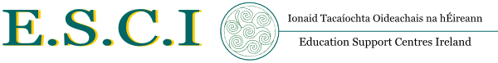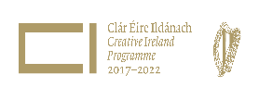

Schools Excellence Fund – Creative Clusters
Guidelines 2022

The purpose and aims of Creative Clusters
The purpose of this pilot scheme is to demonstrate how the creative practices can support clusters of schools to work together to address common learning challenges over a two year period. It aims to:
- Promote new ways of working and collaboration between schools and the arts and cultural sector
- Improve teaching and learning
- Provide an opportunity for clusters of schools to experiment, innovate and collaborate on the design, implementation and evaluation of a bespoke creative learning project
- Develop the creativity of learners and teachers
- Understand, whether clustering schools at different stages of their journey in using the creativity in the classroom and in developing longer term partnerships is an effective model for developing and embedding practice in schools.
The Creative Clusters scheme provides schools with access to creative people, skills and resources and supports them to draw on their own skills and experiences and those within their wider communities.

Background
Creative Clusters is a pilot initiative of the Department of Education led by and in partnership with the 21 full-time Teacher Education Centres (Education Support Centres Ireland - ESCI) and funded through the Schools Excellence Fund – Creative Clusters Initiative.
Creative Clusters is an important initiative of Creative Youth – A Plan to Enable the Creative Potential of Every Child and Young Person, which was published in December 2017 as part of the Creative Ireland Programme. The Creative Youth Plan aims to give every child practical access to tuition, experience and participation in art, music, drama and coding by 2022.

What is a Creative Cluster and how many schools are involved?
A Creative Cluster will typically consist of between three and five schools collaborating on the design, implementation, evaluation and dissemination of an innovative creative learning project which supports them to address a common issue or challenge. Creative Clusters will include schools at different stages of their journey in using creativity in the classroom.
Clusters can consist of primary schools only, post-primary schools only or a combination of primary, post primary schools and youth reach organisations. In selecting the clusters to participate in the scheme, the initiative will seek to have all three configurations represented.
Clusters can be drawn from existing networks or result from the creation of new ones.
Each cluster must nominate a lead school. The lead school must identify a Creative Cluster Coordinator who would normally be a member of the school’s senior leadership team. Substitution costs to the equivalent of 1 day per term for the duration of the pilot project will be provided for the Creative Cluster Coordinator. If the application is successful the co-ordinator will be responsible for managing the day-to-day operation of the project and will act as a single point of contact during the duration of the project. The other schools in each cluster must nominate a representative to participate in the project.

How many Creative Clusters will there be in 2022? It is envisaged a further 21 clusters will be established in 2022.

How long will the Creative Clusters scheme run for?
Clusters established in 2022 will operate for two years.

What is the application process?
Creative Clusters is a national programme of local projects and the 21 full-time Education Support Centres across Ireland are lead partners in the initiative. They will have a key role in identifying and supporting a Creative Cluster for their local area. Individual schools, existing networks of schools and potential clusters of schools must apply to their local full-time Education Support Centre outlining their rationale for taking part in Creative Clusters initiative by 5pm on Friday, 13 May 2022. The List of full-time Education Support Centres and associated contact details are attached in Appendix 1.

Following the application process the local Education Centre will assess and score applications against the criteria below:

- The rationale for the application
This includes the extent to which the school or schools involved have identified a clear rationale for applying to be a Creative Cluster, how this fits with the aims of the initiative and their initial ideas of common issues or learning challenges they could address
- Benefits to teaching and learning
This includes how participation will support improvements in teaching and learning, in the development of creativity and in areas of the curriculum

- Capacity and commitment of all the schools in the cluster to participate
This includes the extent to which the senior leaders in the school or schools are committed to the cluster and to mobilising their school community to engage and how schools in the cluster, who are at different stages of their journey in using the arts and creativity in the classroom, see themselves supporting each other
- Children and Young People’s Voice
This includes the extent to which the application demonstrates a clear plan for ensuring children and young people play a central role in developing, implementing and evaluating their Creative Cluster project.

The local Education Support Centre will then inform the identified cluster in their area. Unsuccessful applicants will also be notified. The completed application must be submitted to your local Education Support Centre [The List of full-time Education Centres and associated contact details are attached in Appendix 1]. The application deadline is 5pm Friday, 13 May 2022.

Which schools are not eligible to apply to lead or participate in a Creative Cluster?
The following schools may not apply to lead or participate in a Creative Cluster:
- Schools not in receipt of capitation grants from the Department of Education / Education and Training Boards and are not in the free-education scheme;
- Schools that are already leading or participating in a Creative Cluster in the 2021/23 school year;
- Schools that are selected to begin participating in the Creative Schools initiative from September 2022;
- Schools who are electing to continue into the second year of Creative Schools (i.e. those who started in September 2021);
- Schools selected to participate in other Schools Excellence Fund initiatives (DEIS, Digital or STEM).

The following schools may apply to lead or participate in a Creative Cluster:
- Schools that have never participated in Creative Schools or Creative Clusters, or are not participating in any other Schools Excellence Fund Initiatives.
- Schools who will have completed their second year of Creative Schools by end of the 2021/22 school year;
- Schools who are completing their second year in the Creative Clusters initiative in the 2021/22 school year, provided that they are applying as part of a cluster of schools who have not yet participated in the initiative. In this instance, it is encouraged that this school applies to lead the new cluster.
What support is provided to the Creative Clusters?
Selected clusters can expect support to include the following:
- An initial one-day regional training event for Creative Cluster Coordinators and at least one representative from each of the schools in the cluster. This will provide an opportunity for schools in the individual Creative Clusters to work together to develop and progress the focus for their cluster work
- A specially trained Creative Cluster Facilitator who will support the cluster for up to three local creative cluster meetings over the 2022-23 school year. The Creative Cluster Facilitator will work with the Cluster to develop, implement and evaluate an arts and creative learning project which helps participating schools to address a common school issue or development need. The Cluster will have flexibility in how they wish to schedule these meeting times and days, in consultation with their local Education Support Centre. Further support from facilitators may be provided in the 2023-2024 school year.
- Paid substitution will be provided for the Regional Cluster Training event and two/three local cluster meetings per school year.
- Networking opportunities with other schools including other Creative Clusters and schools participating in other Creative Youth initiatives to share learning.

What funding is available to each Creative Cluster?
Funding has been set aside for the following:
- Each Creative Cluster will receive funding of €3,000 per school in each cluster over a two-year period to implement their project in the 2022–2024 school years (e.g. a cluster of 3 schools would get €9,000 over two years while a cluster of 5 schools would receive €15,000 over two years). Schools in a cluster are expected to collaborate on how this funding is allocated and spent to support the implementation of their project. Clusters will receive 50% of the total funding in Year 1, with the second 50% being provided in Year 2.
Do clusters have to have a project idea?
This is not a requirement. Those clusters that are selected to take part will begin their journey as a Creative Cluster by participating in a Regional Cluster Training day. On this day the schools in each cluster will spend time working together to identify a focus for their project work as a Creative Cluster.

Assessment and Selection
Creative Cluster applications will be assessed by the Local Education Support Centre. Applications will be assessed and scored against the criteria below.

- The rationale for the application
This includes the extent to which the school(s) involved have identified a clear rationale for applying to be a Creative Cluster and their initial ideas of common issues or learning challenges they could address
- Benefits to teaching and learning
This includes how participation will support improvements in teaching and learning, in the development of the arts and creativity and in areas of the curriculum

- Capacity and commitment of all the schools in the cluster to participate
This includes the extent to which the senior leaders in each of the schools are committed to the cluster and to mobilising their school community to engage and how schools in the cluster, who are at different stages of their journey in using the arts and creativity in the classroom, see themselves supporting each other
- Children and Young Peoples Voice
This includes the extent to which the application demonstrates a clear plan for ensuring children and young people play a central role in developing, implementing and evaluating their Creative Cluster project.

Creative Clusters Timeline
Closing date for applications 13 May 2022
Announcement of Creative Clusters 21 March 2022
Regional Training for Creative Clusters Late September/Early October 2022
Detailed project planning and implementation work begins October 2022
Initiative completion and review May 2024

Appendix 1 – List of full-time Education Centres and associated contact details
Education Centre | Address | Phone | email | Website
Athlone | Moydrum Road, Athlone, Co Westmeath | 090 6420400 | info@athloneeducationcentre.com | www.athloneeducationcentre.com
Blackrock | Kill Avenue, Dún Laoghaire, Co Dublin | 01 2365000 | bec@blackrockec.ie | www.blackrockec.ie
Carrick-on-Shannon | Marymount, Old Dublin Road, Carrick-on-Shannon, Co Leitrim | 071 9620383 | office@carrickedcentre.ie | www.carrickedcentre.ie
Clare | Government Buildings, Kilrush Road, Ennis, Co Clare | 065 6845500 | reception@clareed.ie | www.clareed.ie
Cork | The Rectory, Western Road, Cork | 021 4255600 | office@cesc.ie | www.cesc.ie
Donegal | 2/3 Floor, Pier One, Quay Street, Donegal Town, Co Donegal | 074 9723487 | admin@donegaledcentre.ie | www.donegaledcentre.ie
Drumcondra | Drumcondra, Dublin 9 | 01 8576400 | info@ecdrumcondra.ie | www.ecdrumcondra.ie
Dublin West | Old Blessington Road, Tallaght, Dublin 24 | 01 4528000 | reception@dwec.ie | www.dwec.ie
Galway | Cluain Mhuire, Wellpark, Galway, Co Galway | 091 745600 | info@galwayec.ie | www.galwayec.ie
Kildare | Friary Road, Kildare Town, Co Kildare | 045 530200 | office@eckildare.ie | www.eckildare.ie
Kilkenny | Seville Lodge, Callan Road, Kilkenny, Co Kilkenny | 056 7760200 | kecsec@eckilkenny.ie | www.eckilkenny.ie
Laois | Block Road, Portlaoise, Co Laois | 057 8672400 | info@laoisedcentre.ie | www.laoisedcentre.ie
Limerick | 1st Floor Marshall House, Dooradoyle Road, Limerick, Co Limerick | 061 585060 | info@lec.ie | www.lec.ie
Mayo | Westport Road, Castlebar, Co Mayo | 094 9020700 | eolas@mayoeducationcentre.ie | www.mayoeducationcentre.ie
Monaghan | Knockaconny, Armagh Road, Monaghan, Co Monaghan | 047 74000 | info@metc.ie | www.metc.ie
Navan | Athlumney, Navan, Co Meath | 046 9067040 | info@ecnavan.ie | www.ecnavan.ie
Sligo | Ballinode, Sligo, Co Sligo | 071 9138700 | info@ecsligo.ie | www.ecsligo.ie
Tralee | North Campus, Dromtacker, Tralee, Co Kerry | 066 7195000 | info@edcentretralee.ie | www.edcentretralee.ie
Waterford | Newtown Road, Waterford, Co Waterford | 051 311000 | info@wtc.ie | www.wtc.ie
West Cork | The Square Shopping Centre, The Square, Dunmanway, Co Cork | 023 8856756 | info@westcorkeducationcentre.ie | www.westcorkeducationcentre.ie
Co. Wexford | Milehouse Rd, Enniscorthy, Co Wexford | 053 9239100 | info@ecwexford.ie | www.ecwexford.ie

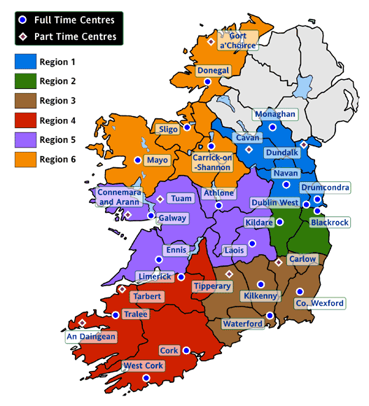

The Creative Schools initiative is an initiative led by the Arts Council that supports individual schools to develop and begin to implement their own Creative Schools plan.

