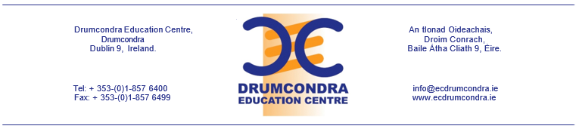

Application form for the position of:

Administrative Assistant in Drumcondra Education Support Centre

Name of applicant: ____________________________

Completed application forms should be submitted in electronic format by 5pm Wednesday 4th October to recruitment@ecdrumcondra.ie

- Deletion/amendment of any part of this form (other than to add rows) will invalidate this application.
- Receipt of completed application forms will be acknowledged.
- Late or incomplete applications will not be considered.
- Only information submitted on the application form will be considered.
- Incorrect information supplied in this Application Form will lead to disqualification.
- Canvassing, either directly or indirectly, will disqualify.
- If you have a disability which requires reasonable adjustments at the selection interview, or which needs to be taken into account when considering your application, please inform Drumcondra Education Support Centre in advance.
- Drumcondra Education Support Centre is an equal opportunities employer.

Office Use Only | Date Received
 | Application Number

- Personal Details

Name

Address

Telephone Numbers | Home | Mobile
E-Mail

- Educational Qualifications – include second level/FET/third level (if applicable)
Year(s) | Qualification | School/College | Subjects | Level/Grade

- Employment Experience – most recent first
Year(s) | Duration | Employer | Main Duties and Responsibilities

- Professional Training and Courses completed
Course Title | Course Content | Institution/Agency | Date From/To

- Please give details of your administration & ICT skills.

- Please give details of your organisational and interpersonal skills

- Please give details of your Financial/ bookkeeping/ accounts Experience

- Please provide any other details that are relevant to this application.

- Details of two people from whom references may be obtained.
1.
Referee’s Name
Position
Address
Telephone Number(s)
E-mail Address
2.
Referee’s Name
Position
Address
Telephone Number(s)
E-mail Address

Drumcondra Education Support Centre reserves the right to seek additional referees if deemed appropriate e.g. current or former employers

I hereby certify that all information provided on this application form is true and correct:

Signature of Applicant:

Date:

